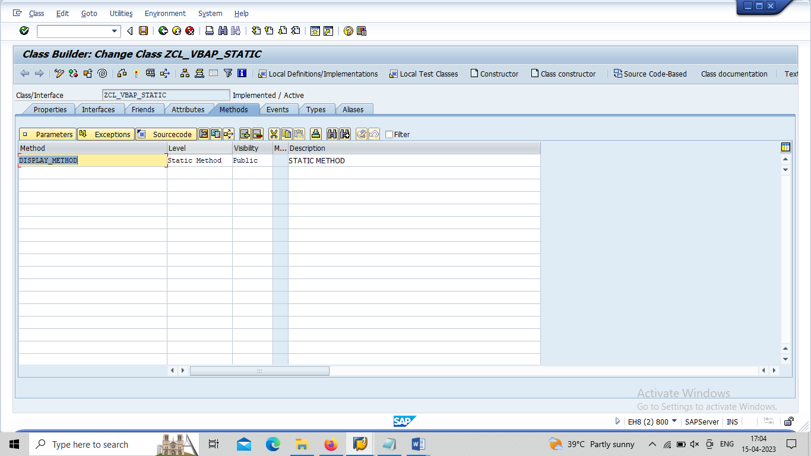

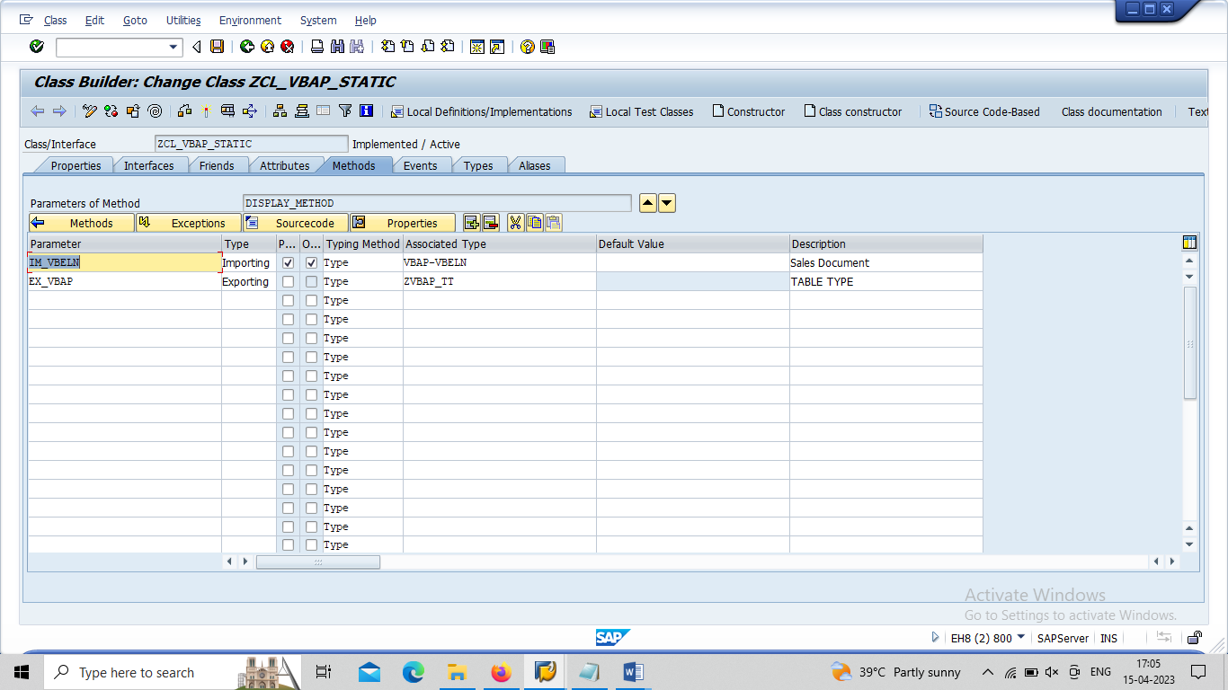

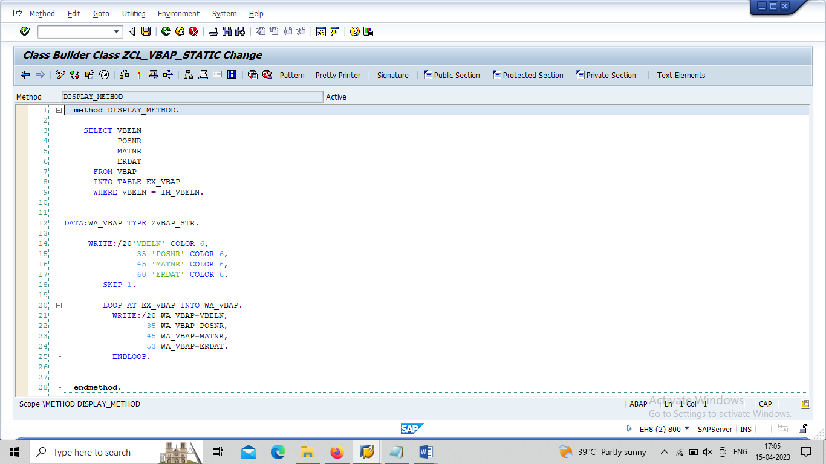

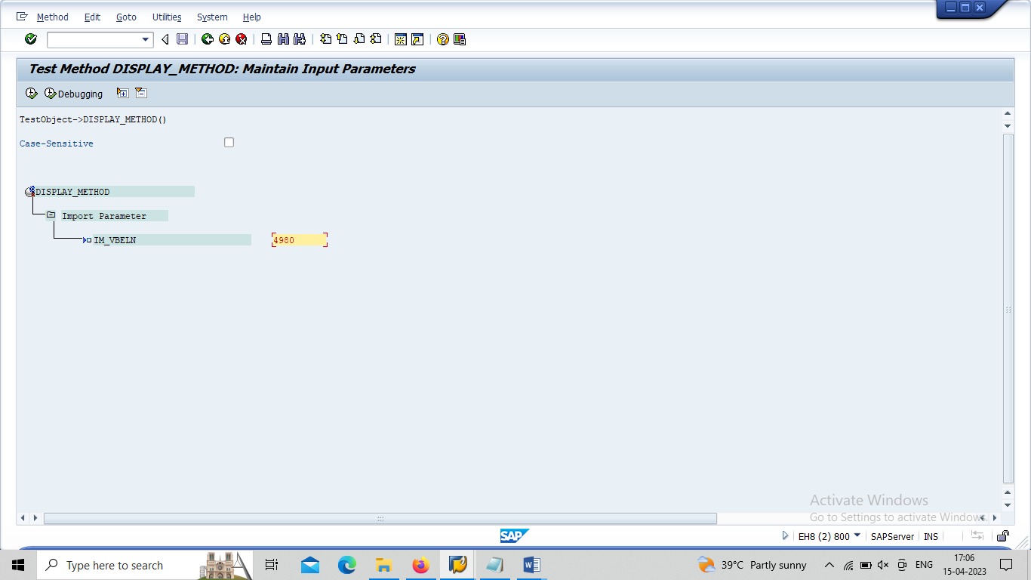

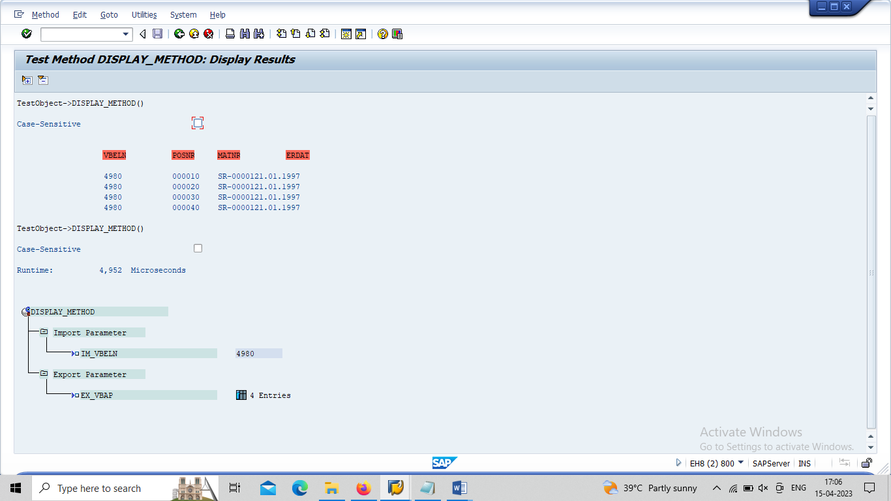

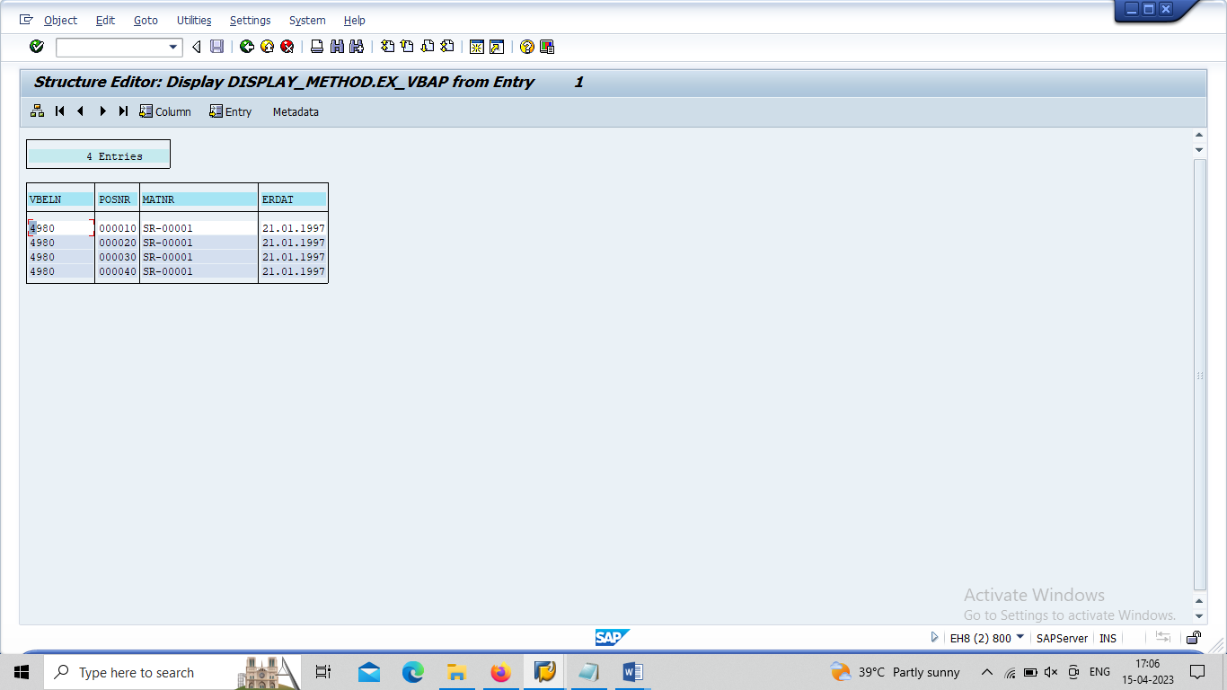

REPORT Z23_OOABAP_DEMO_05_GL.
PARAMETERS: P_VBELN TYPE VBAP-VBELN.
DATA : IT_VBAP TYPE ZVBAP_TT,
WA_VBAP TYPE ZVBAP_STR.
CALL METHOD ZCL_VBAP_STATIC=>DISPLAY_METHOD "=>STATIC OPERATOR
EXPORTING
IM_VBELN = P_VBELN
IMPORTING
EX_VBAP = IT_VBAP.
.

